머신러닝및응용 HW#3

201524404 강민진

교과서 527page

**13.8 Given the full joint distribution shown in Figure 13.3, calculate the following:**

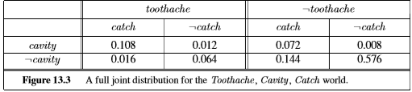

**a.** *P***(toothache)**

**b. P(Cavity)**

**c. P(Toothache | cavity)**

**d. P(Cavity | toothache V catch).**

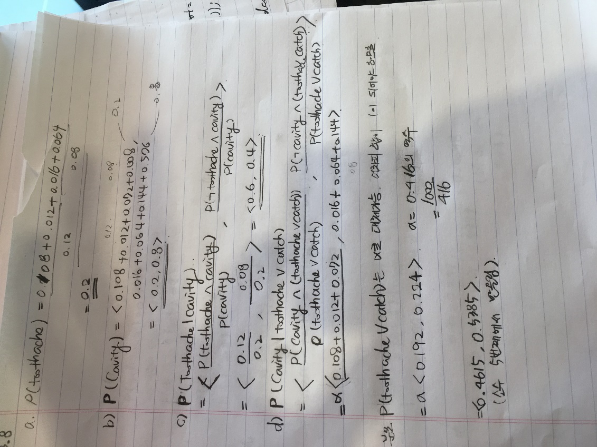

**13.15 After your yearly checkup, the doctor has bad news and good news. The bad news is that you tested positive for a serious disease and that the test is 99% accurate (i.e., the probability of testing positive when you do have the disease is 0.99, as is the probability of testing negative when you don’t have the disease). The good news is that this is a rare disease, striking only 1 in 10,000 people of your age. Why is it good news that the disease is rare? What are the chances that you actually have the disease?**

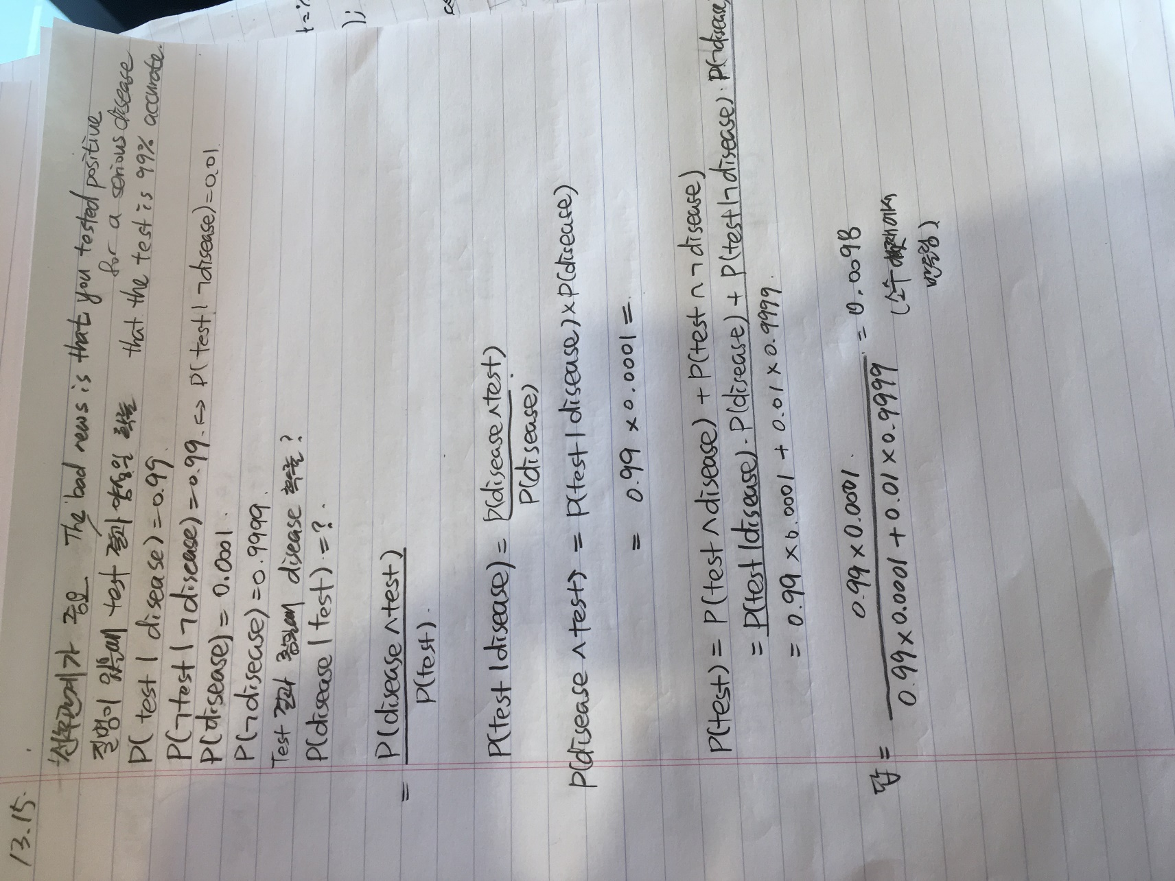

**13.16 It is quite often useful to consider the effect of some specific propositions in the context of some general background evidence that remains fixed, rather than in the complete absence of information. The following question ask you to prove more general versions of the product rule and Bayes’ rule, with respect to some background evidence e:**

**a. Prove the conditionalized version of the general product rule:**

**P(X, Y | e) = P(X | Y, e)P(Y | e).**

**b. Prove the conditionalized version of Bayes’ rule in Equation(13.13).**



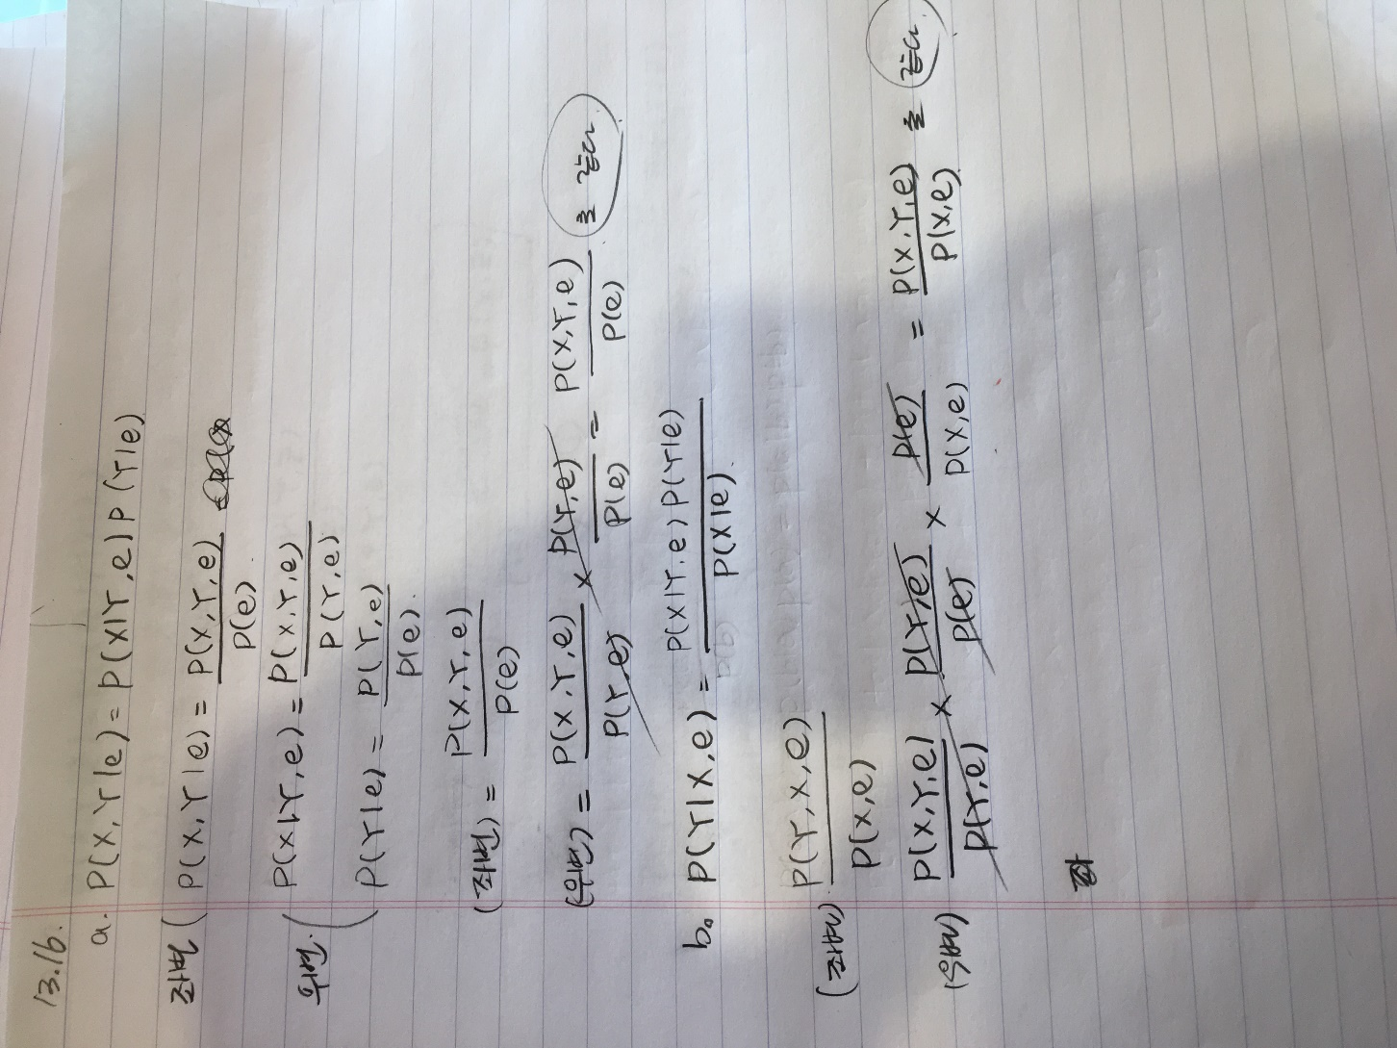

**13.17 Show that the statement of conditional independence**

**P(X,Y | Z) = P(X | Z)P(Y | Z)**

**is equivalent to each of the statements**

**P(X | Y, Z) = P(X | Z) and P(Y | X, Z) = P(Y | Z).**

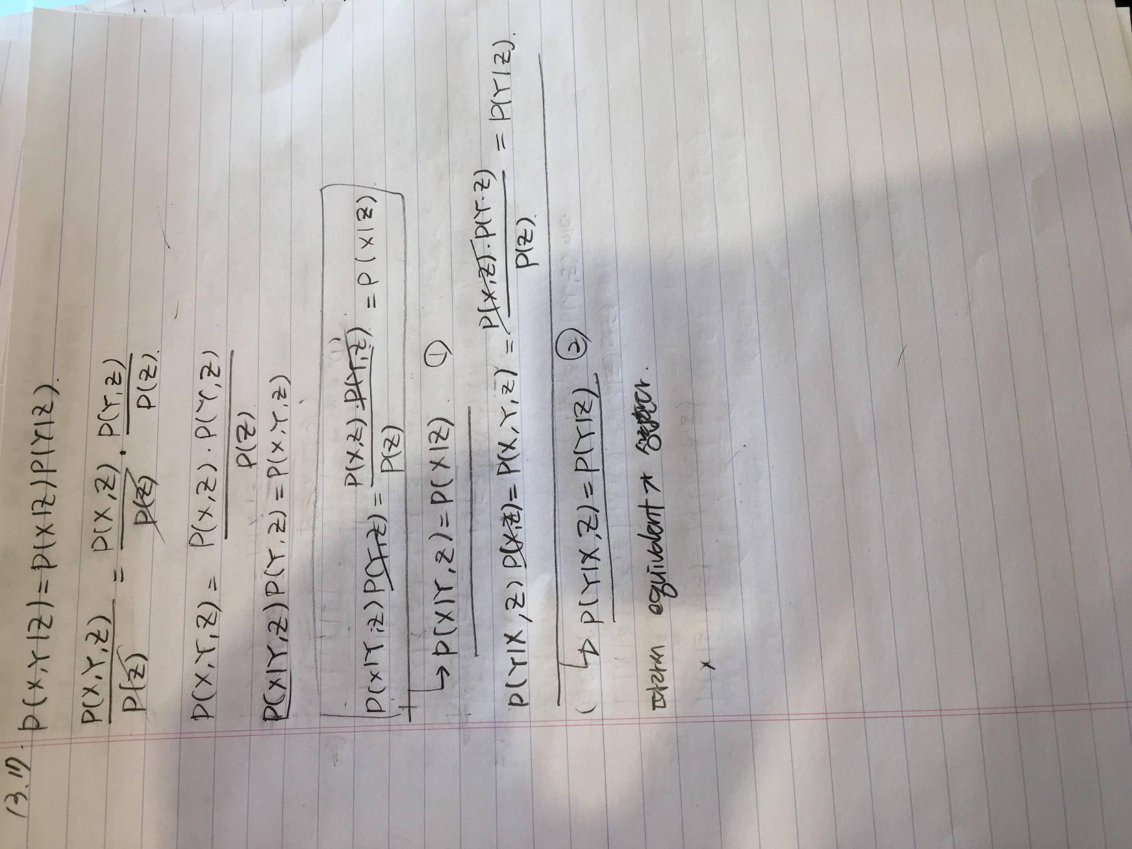

**13.19**

**In this exercise, you will complete the normalization calculation for the meningitis example, First, make up a suitable value for P(s|¬m), and use it to calculate unnormalized values for P(m|s) and P(¬m|s) (i.e., ignoring the P(s) term in the Bayes’ rule expression, Equation (13.14)). Now normalize these values so that they add to 1.**

